No More Water Bill Surprises!
Sign-Up For The [Utility/City] Consumer Water Portal and
Take Control of Your Water Usage
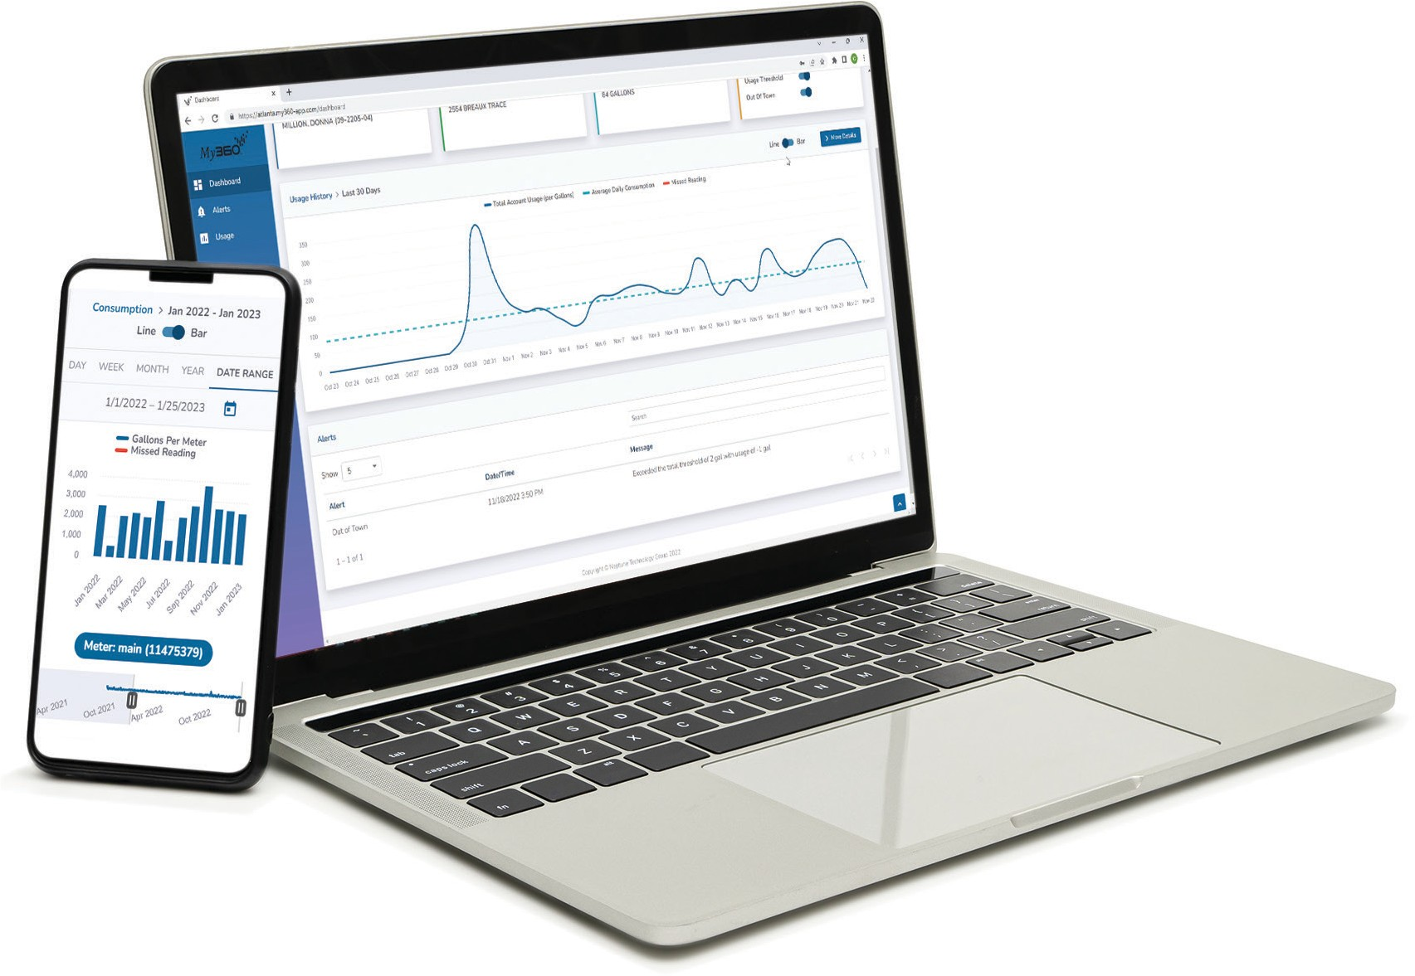
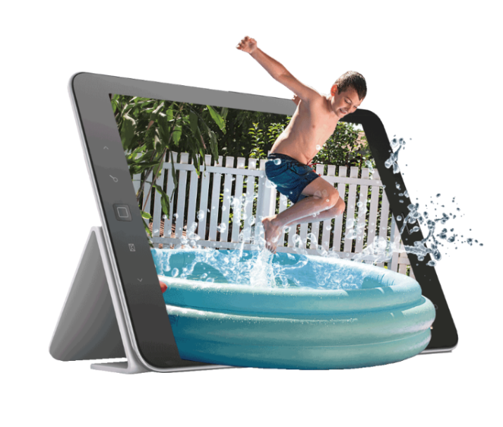

Learn more about your water habits and conserve water with the [Utility/City] Consumer Water Portal. Access your water consumption data 24/7, from any device with internet, and gain useful insights and peace of mind.
With your water consumption data at your fingertips, you can find answers to questions about your account without having to call or visit the utility. In addition, the [Utility/City] Consumer Water Portal offers the following benefits.
- View and manage your water usage 24/7 with an intuitive dashboard featuring charts and graphs | - Access easily from any desktop, laptop, tablet, or mobile device
- Monitor multiple properties from one account | - Manage multiple meters to get a better understanding of your water usage
- Set out-of-town alerts to monitor consumption and detect potential leaks | - Create water threshold alerts to set a water budget, help save water, and eliminate bill surprises

Activate your [Utility/City] portal account today,
go to [website]
Have your water bill handy. You will need your account number
and either your full name or street address.

